INDIAN SCHOOL AL WADI AL KABIR
Class: VI | Department : Computer Science | Year :2022-2023
Holiday Homework | Topic: Excel-Functions & Formulas
1.Open Excel & Create the following worksheet.
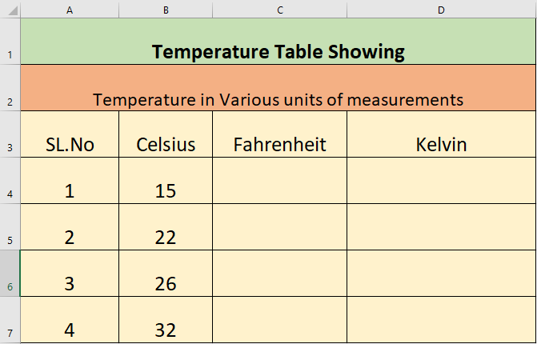
- Convert the temperature in column B from Celsius to Fahrenheit in column C,by using the formula : Fahrenheit =9/5*Celsius
- Convert the temperature in column B from Celsius to Kelvin in column D, by using the formula
Kelvin=Celsius + 273.15

